

**COLLEGE OF ARTS AND SCIENCES**

**SCHOOL OF COMPUTING (SOC)**

**STIW2044 MOBILE PROGRAMMING**

**SEMESTER A182 SESSION 2018/2019**

**Lab Assignment 1**

**PREPARED BY:**

**OOI YAO PENG (245771)**

**PREPARED FOR:**

**MR. AHMAD HANIS BIN MOHD SHABLI**

**SUBMITTION DATE:**

**24 FEBRUARY 2019**

**TABLE OF CONTENT**

|  |  |  |
| --- | --- | --- |
| **NO** | **CONTENT** | **PAGE** |
| **1.0** | **Layout Design & Blueprint** | **1** |
| **2.0** | **Activity_main.xml** | **2 - 4** |
| **3.0** | **Java source code** | **5 - 6** |
| **4.0** | **Output/Result** | **7 - 8** |
| **5.0** | **Github Link** | **8** |

1.0 Layout Design & Blueprint

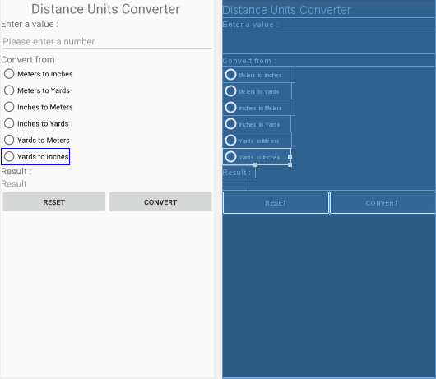

2.0 activity_main.xml

*<?***xml version="1.0" encoding="utf-8"***?>*<**ScrollView xmlns:android="http://schemas.android.com/apk/res/android"  
 xmlns:app="http://schemas.android.com/apk/res-auto"  
 xmlns:tools="http://schemas.android.com/tools"  
 android:layout_width="match_parent"  
 android:layout_height="match_parent"  
 tools:context=".MainActivity"**>  
  
 <**LinearLayout  
 android:layout_width="match_parent"  
 android:layout_height="wrap_content"  
 android:orientation="vertical"**>  
  
 <**TextView  
 android:id="@+id/TextView"  
 android:layout_width="match_parent"  
 android:layout_height="wrap_content"  
 android:layout_gravity="center"  
 android:gravity="center"  
 android:text="Distance Units Converter "  
 android:textSize="26sp"** />  
  
 <**TextView  
 android:id="@+id/textView2"  
 android:layout_width="match_parent"  
 android:layout_height="wrap_content"  
 android:text="Enter a value : "  
 android:textSize="18sp"** />  
  
 <**EditText  
 android:id="@+id/value"  
 android:layout_width="match_parent"  
 android:layout_height="wrap_content"  
 android:ems="10"  
 android:hint="Please enter a number"  
 android:inputType="numberDecimal"** />  
  
 <**TextView  
 android:id="@+id/textView3"  
 android:layout_width="match_parent"  
 android:layout_height="wrap_content"  
 android:text="Convert from :"  
 android:textSize="18sp"** />  
  
 <**RadioGroup  
 android:id="@+id/converter"  
 android:layout_width="match_parent"  
 android:layout_height="match_parent"** >  
  
 <**RadioButton  
 android:layout_width="wrap_content"  
 android:layout_height="wrap_content"  
 android:layout_weight="1"  
 android:text="Meters to Inches"** />  
  
 <**RadioButton  
 android:id="@+id/radioButton2"  
 android:layout_width="wrap_content"  
 android:layout_height="wrap_content"  
 android:layout_weight="1"  
 android:text="Meters to Yards"** />  
  
 <**RadioButton  
 android:id="@+id/radioButton3"  
 android:layout_width="wrap_content"  
 android:layout_height="wrap_content"  
 android:layout_weight="1"  
 android:text="Inches to Meters"** />  
  
 <**RadioButton  
 android:id="@+id/radioButton4"  
 android:layout_width="wrap_content"  
 android:layout_height="wrap_content"  
 android:layout_weight="1"  
 android:text="Inches to Yards"** />  
  
 <**RadioButton  
 android:id="@+id/radioButton5"  
 android:layout_width="wrap_content"  
 android:layout_height="wrap_content"  
 android:layout_weight="1"  
 android:text="Yards to Meters"** />  
  
 <**RadioButton  
 android:id="@+id/radioButton6"  
 android:layout_width="wrap_content"  
 android:layout_height="wrap_content"  
 android:layout_weight="1"  
 android:text="Yards to Inches"** />  
  
 <**TextView  
 android:id="@+id/Result"  
 android:layout_width="wrap_content"  
 android:layout_height="wrap_content"  
 android:layout_weight="1"  
 android:text="Result : "  
 android:textSize="18sp"** />  
  
 <**TextView  
 android:id="@+id/viewResult"  
 android:layout_width="wrap_content"  
 android:layout_height="wrap_content"  
 android:layout_weight="1"  
 android:hint="Result"  
 android:textSize="18sp"** />  
  
 </**RadioGroup**>  
  
 <**LinearLayout  
 android:layout_width="match_parent"  
 android:layout_height="match_parent"  
 android:layout_weight="1"  
 android:orientation="horizontal"**>  
  
 <**Button  
 android:id="@+id/resetBTN"  
 android:layout_width="wrap_content"  
 android:layout_height="wrap_content"  
 android:layout_weight="1"  
 android:text="RESET"** />  
  
 <**Button  
 android:id="@+id/convertBTN"  
 android:layout_width="wrap_content"  
 android:layout_height="wrap_content"  
 android:layout_weight="1"  
 android:text="CONVERT"** />  
  
 </**LinearLayout**>  
  
 </**LinearLayout**>  
</**ScrollView**>

3.0 Java Source Code

MainActivity.Java

**package** com.example.assignment1;  
  
**import** android.content.DialogInterface;  
**import** android.support.v7.app.AlertDialog;  
**import** android.support.v7.app.AppCompatActivity;  
**import** android.os.Bundle;  
**import** android.view.View;  
**import** android.widget.Button;  
**import** android.widget.EditText;  
**import** android.widget.RadioButton;  
**import** android.widget.RadioGroup;  
**import** android.widget.TextView;  
  
**public class** MainActivity **extends** AppCompatActivity {  
  
 @Override  
 **protected void** onCreate(Bundle savedInstanceState) {  
 **super**.onCreate(savedInstanceState);  
 setContentView(R.layout.***activity_main***);  
 **final** EditText value = (EditText) findViewById(R.id.***value***);  
 **final** RadioGroup rg = (RadioGroup) findViewById(R.id.***converter***);  
 **final** RadioButton rb1 = (RadioButton) findViewById(R.id.***radiobutton***);  
 **final** RadioButton rb2 = (RadioButton) findViewById(R.id.***radioButton2***);  
 **final** RadioButton rb3 = (RadioButton) findViewById(R.id.***radioButton3***);  
 **final** RadioButton rb4 = (RadioButton) findViewById(R.id.***radioButton4***);  
 **final** RadioButton rb5 = (RadioButton) findViewById(R.id.***radioButton5***);  
 **final** RadioButton rb6 = (RadioButton) findViewById(R.id.***radioButton6***);  
 **final** TextView viewResult = (TextView)findViewById(R.id.***viewResult***);  
  
 Button convert = findViewById(R.id.***convertBTN***);  
 convert.setOnClickListener(**new** View.OnClickListener() {  
 @Override  
 **public void** onClick(View v) {  
 **double** v1 = **new** Double(value.getText().toString());  
  
 **if** (rb1.isChecked())  
 {  
 v1 = unitConverter.*convertMetersToInches*(v1);  
 }  
 **else if** (rb2.isChecked())  
 {  
 v1 = unitConverter.*convertMetersToYards*(v1);  
 }  
 **else if** (rb3.isChecked())  
 {  
 v1 = unitConverter.*convertInchesToMeters*(v1);  
 }  
 **else if** (rb4.isChecked())  
 {  
 v1 = unitConverter.*convertInchesToYards*(v1);  
 }  
 **else if** (rb5.isChecked())  
 {  
 v1 = unitConverter.*convertYardsToMeters*(v1);  
 }  
 **else if** (rb6.isChecked())  
 {  
 v1 = unitConverter.*convertYardsToInches*(v1);  
 }  
 **else** {  
 AlertDialog alertDialog = **new** AlertDialog.Builder(MainActivity.**this**).create();  
 alertDialog.setTitle(**"Alert"**);  
 alertDialog.setMessage(**"Please select the convert button"**);  
 alertDialog.setButton(AlertDialog.***BUTTON_NEUTRAL***, **"OK"**,  
 **new** DialogInterface.OnClickListener() {  
 **public void** onClick(DialogInterface dialog, **int** which) {  
 dialog.dismiss();  
 }  
 });  
 alertDialog.show();;  
 }  
  
 viewResult.setText(**""**+v1);  
 }  
 });  
  
 Button reset = (Button)findViewById(R.id.***resetBTN***);  
 reset.setOnClickListener(**new** View.OnClickListener() {  
 @Override  
 **public void** onClick(View v) {  
 value.setText(**""**);  
 viewResult.setText(**""**);  
 rg.clearCheck();  
 }  
 });  
 }  
}

unitConverter.Java

**package** com.example.assignment1;  
  
**public class** unitConverter {  
  
 **public static double** convertMetersToInches(**double** value){  
 **return** value*39.3701;  
 }  
  
 **public static double** convertMetersToYards(**double** value){  
 **return** value*1.09361;  
 }  
  
 **public static double** convertInchesToMeters(**double** value){  
 **return** value*0.0254;  
 }  
  
 **public static double** convertInchesToYards(**double** value){  
 **return** value*0.027778;  
 }  
  
 **public static double** convertYardsToMeters(**double** value){  
 **return** value*0.9144;  
 }  
  
 **public static double** convertYardsToInches(**double** value){  
 **return** value*36;  
 }  
}

4.0 Output/Result

a. User input 23 and select Meters to Inches button

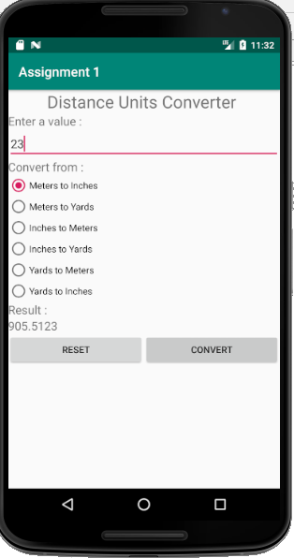

b. User input 45 and select Inches and Yards button

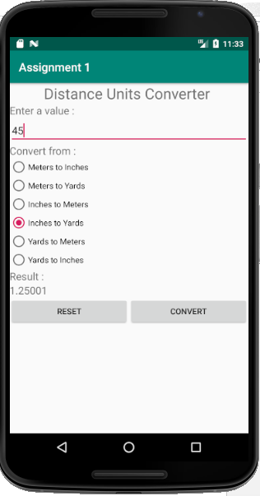

c. a. User input 55 and select Inches to Yards button

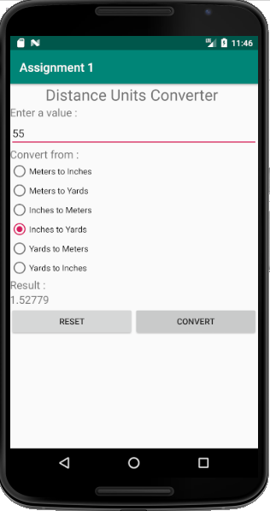

4.0 Github Link

<https://github.com/yaopeng96/STIW2044_Lab_Assignment1>